Written Lab 7: Lab on Switches

Key Networking Terms:

1. Address Learning
   1. When a switch keeps track of where a packet has come from/who sent something. This helps to build tables and learn the network, for forwarding,
2. Forward/filter
   1. When a switch passes a packet towards its destination. This allows switched to “direct” traffic in a network.
3. Loop avoidance
   1. This function is provided by Spanning Tree Protocol (STP) to prevent loops in communication. This is important because one can create a network with multiple points of failure for better robustness, without having to worry about loops eating bandwidth.
4. Port-Security
   1. A method/command to control the security on an interface/port. This allows administrators to limit who and how many (MACs) can access a certain port. There are different modes/procedures for violations
      1. Protect= just drop unknown packets
      2. Restrict= drop packets AND log the violation with a trap message (notification).
      3. Shutdown= DEFAULT; this mod shuts down the port associated with the error AND logs the error, like in Restrict
5. Frame Tagging
   1. A method designed to ease the handling of multiple VLANs. This method adds another layer to the destination by adding in a number corresponding to a particular VLAN. Once the frame reaches the desired VLAN indicated by the tag, it then drops the tag and proceeds toward its destination. Trunk ports are great because they support tagged and untagged traffic.

Procedures:

1. Lab Simulation #2
   1. Backups
   2. Starting configuration:
      1. On the Switch:
         1. running-config
         2. All 24 FastEthernet, and 2 Gig interfaces enabled
         3. Device IPs set to 10.10.90.10/24 and 10.10.90.20/24
         4. sCorp vlan 1 IP: 10.10.90.3/24
         5. User exec password: net; priv exec password 343
         6. MOTD and clock set
         7. Console and all vty (telnet/ssh) lines have passwords
   3. Lab Procedures:
      1. Setup and backup switch startup config to a tftp server

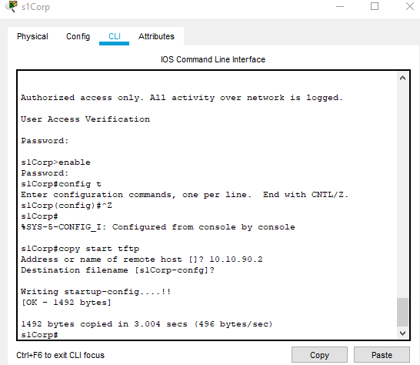

* + 1. Get backup from tftp server

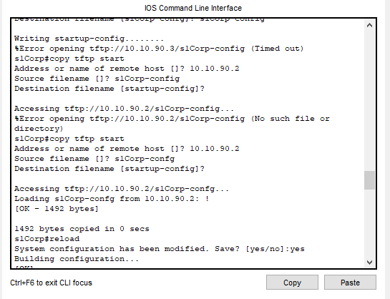

* + 1. Get IOS file name and backup to tftp

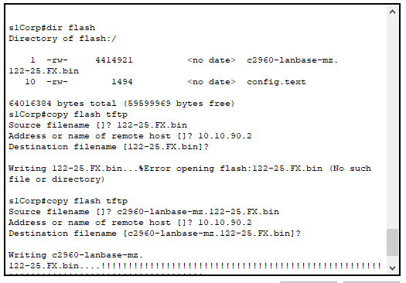

1. Lab Simulation #3
   1. Security
   2. Starting configuration:
      1. On the Switch:
         1. running-config
         2. All 24 FastEthernet, and 2 Gig interfaces enabled
         3. Device IPs set to 10.10.90.10/24 and 10.10.90.20/24
         4. sCorp vlan 1 IP: 10.10.90.3/24
         5. User exec password: net; priv exec password 343
         6. MOTD and clock set
         7. Console and all vty (telnet/ssh) lines have passwordsLab
   3. Procedures:
      1. Enable security on port fa0/10

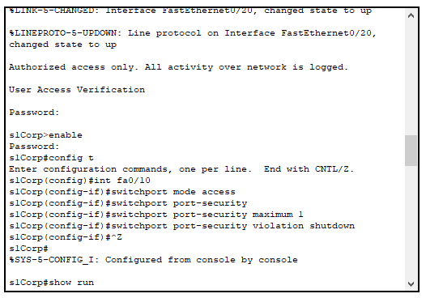

* + 1. Learn mac address of IP on 10 and check

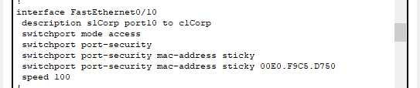

* + 1. Try connecting a laptop to port 10, and see that it cannot ping outside of itself because of the address limit.

Conclusions and Discussion:

This chapter has made me ponder the ease of configuring a network. This comes from many of my plug-and-play experiences, now being challenged by the actual work that goes into creating a corporate or just thorough and secure network. I know we have not messed with anything even close to the complexity of a company, but learning about all the security measures and steps needed to create sections, like by VLANS, makes me respect those in this field even more. This doesn’t mean that I have struggled with the content, the videos are helpful and I am walked through each step; but I have learned how tedious it can be to set up even a tiny network with the ease of simulation software.

This chapter has taught me to be thorough and detailed. The many aspects of not only each device, but each port has made me realize that having a plan and furnishing that plan before implementing it, is key in creating a network. I noticed I would lose my place if I didn’t keep reminding myself of what IP was where, and I can only imagine how it would be if hundreds of devices were on a network.

As I mentioned in my last report, the labs really have helped solidify the readings. It is one thing to read about how to do a procedure, but actually doing it is far more beneficial for me. The act of doing the tasks helps me learn about different responses that I could actually get and what the interfaces look like. I was so excited to learn about the command that stopped the CLI to search for a DNS when an incorrect command was give; I ran into that so many times in the first lab. I thought it was neat to see how router-on-a-stick was created, I have heard about it for a few years now; it makes me think of the router as a post office with top secret info, like who they are the only ones that know the grand plan of all the pieces in play.

…

Feedback:

